Table of Contents

**Grading sheet1,2**

**Table of Contents3**

**Cover Page4**

**Abstract5**

**Gantt Chart5**

**Introduction6**

**Work Description9**

**Considered Designs vs Final Designs13**

**Design Photos13**

**Testing and Results14**

**Member Contributions15**

**Conclusions and Recommendations15**

**References16**

**Tables:**

**(1)10**

**(2)10**

**(3)11**

**(4)11**

**(5)13**

**(6)14**



**Project Final Report:**

LABVIEW-Simulated Elevator (Three Floors)

By:

Group 10

Course: EECE 200

Thursday, January 26, 2011

**Abstract:**

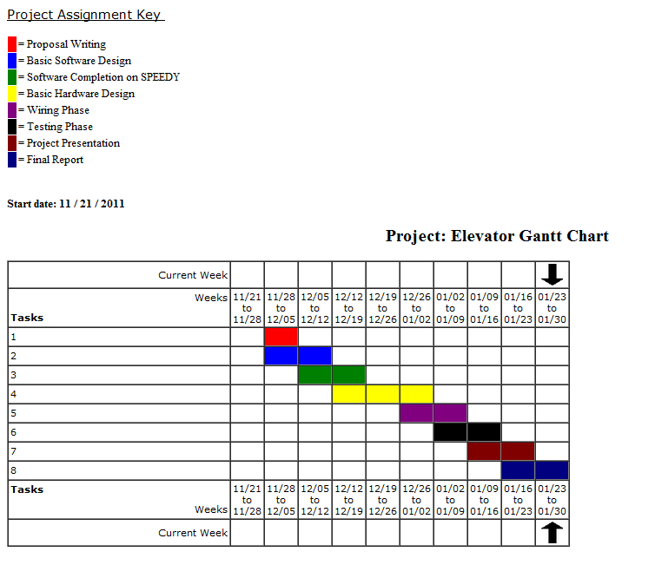This is the final report of the semester’s project; a LABVIEW simulated elevator with associated hardware. The project has spanned over a two month time interval; starting with the proposal and ending with this report. The beginning phase which was writing the proposal, was were all thoughts were brainstormed and jotted down on paper; still not concrete ideas waiting to be manifested. After finishing the proposal, and grasping some clues and sense on what was really needed to be done to structure an elevator using both software and hardware, we proceeded into the software phase. This is where a deeper understanding of LABVIEW came into play, and problem-solving through logic was needed. When the software was done with and tested on the SPEEDY board, the associated hardware building process began. After a load of blood, sweat, and tears the software and hardware were ready to be matched. Afterwards, a Powerpoint presentation was prepared and the speeches were divided among us. All what was left is the following finalization report.

**Introduction:**

**Problem Statement:**

In the shadow of the constant evolution of constructions and the ever-evolving phenomenon of skyscrapers, modern buildings have been constantly towering higher and higher with the will to fit more families and individuals. Ten, fifty, and even hundred floor buildings have been successfully constructed, which raises a question: How will the residents (of all types: too old, too young unhealthy…) be able to “climb” to their apartments? Well the answer is the use of elevators of course. As simple as this answer might seem, its complexity of building and programming overwhelms its simplicity in saying. In short, a three floor elevator project simulated by LABVIEW would represent a resemblance to all elevators that we rely on each day, which are problem-solvers for mankind. It’s time to find out the complex language that the elevator speaks to itself as a result of a simple push of a button.

**Project Objectives:**

* **Curricular Objectives:**

1. Designing a fully-functional elevator.
2. Controlling the following in the designed elevator:
   1. The doors: They must open automatically by the application of motion sensors.
   2. The motor: It must respond correctly to the desired motion of the elevator, according to the floor where the “CALL” button was pressed. That is, the motor must have the ability to rotate in both ways.
   3. The fan: It must operate automatically when needed, by applying heat sensors.
3. Creating a suitable LABVIEW VI to control the designed elevator through SPEEDY.
4. Linking the VI and the elevator and testing them to ensure functionality.

* **Extracurricular Objectives:**

1. Learning the value of teamwork in the workplace and the necessity to trust others as individuals to get their part done, and not to disappoint them by getting your recommended part done as well.
2. Learning to be independent and not to be spoon-fed or take everything for granted: Obviously, this project is no simple one, and not all steps will be taught in the given courses, which pushes the group to do some researching and trial-and-error experiments to discover the right methods by themselves.
3. Simply having fun and feeling the pleasure of being an engineer! It might not seem professional to say this but it has to be said nonetheless: The real pleasure of engineering is not memorizing solid formulas and dealing with resulting numbers, the pleasure of engineering lies in building a project with your bare hands and staying up late to make it work properly.

**Specifications:**

1. Inputs:
   1. A motion sensor digital input installed on the door of the elevator to detect motion and open.
   2. A temperature sensor installed in the elevator to detect increase in temperature and turn on the fan.
   3. One digital input per floor to determine the position of the elevator cabin.
   4. One digital input per floor to act as the “CALL” button.
   5. An analog audio input from inside the elevator allowing it to move according to the order given from inside the cabin.
2. Outputs:
   1. A digital output that turns the motor of the elevator on and off.
   2. A digital output to turn the ventilation system (fan) on and off.
   3. Two digital outputs to display the floor number the elevator is currently on.
   4. One digital output per floor to open and close the elevator doors.
   5. One digital output which controls the direction of rotation of the motor (lifting the elevator up or down)

**Project Constraints:**

1. Only one SPEEDY is allowed per group which makes it a challenge to fit all the needed inputs and outputs on such a limited board.
2. It is not allowed to borrow the SPEEDY but required to work with it during university and that is an obstacle.
3. All the wires and connections must be well hidden to seem like a realistic design.

**Work Description:**

1. Software:
   1. Brainstorming was done and the following was come up with:
      1. The entire program must be inside one while loop
      2. The seven second delay must be implemented using a tick count block
      3. Logic gates (and, or…) , local variables, and case structures will be the main basis of the program
   2. Then a picture acquired from a presentation done by the department about the project was used:

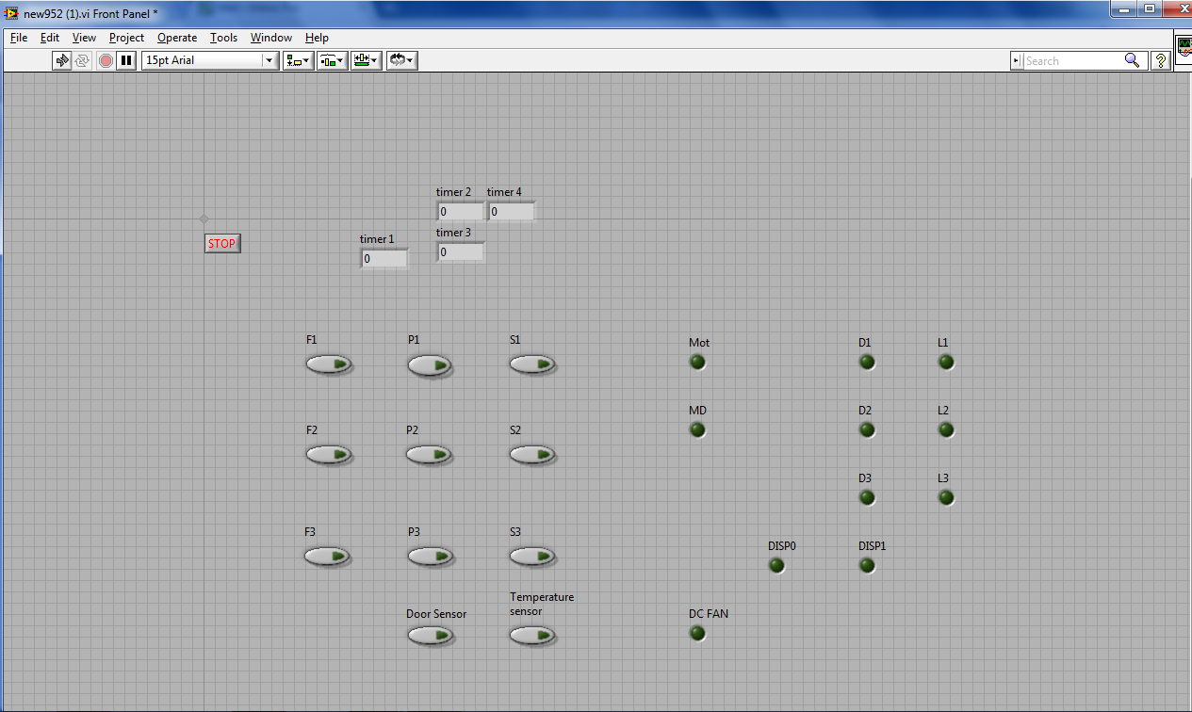

* 1. Then, the work was started backwards, from the given photo in order to reach the functioning program. For that to happen, truth tables were needed for every element:

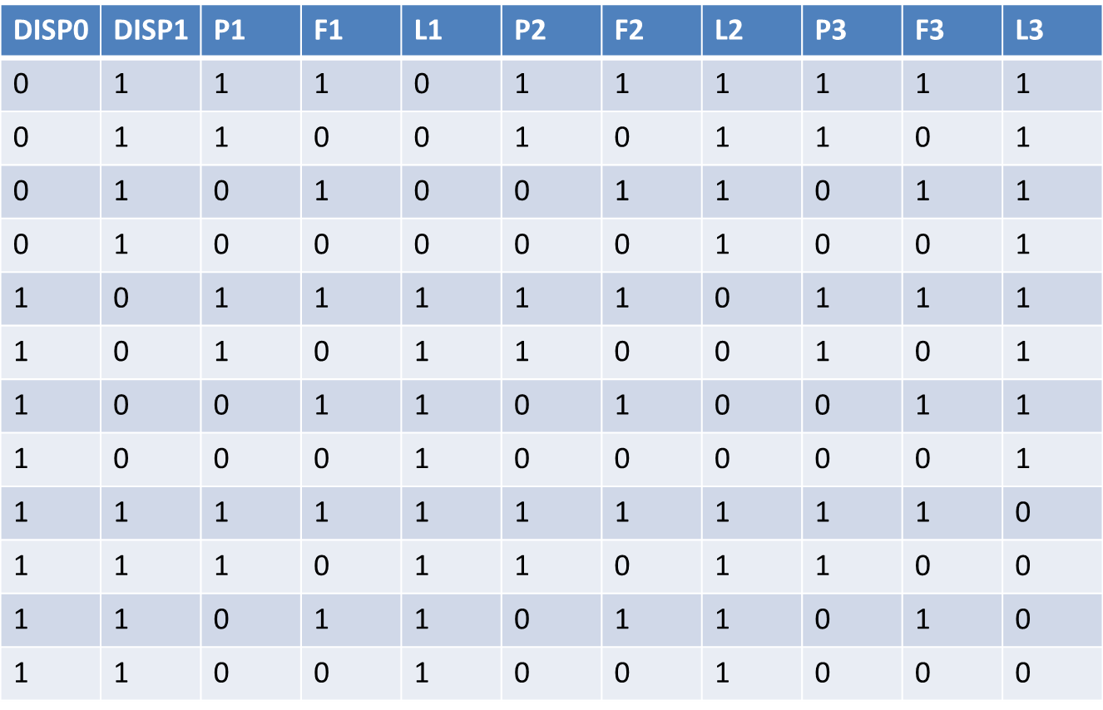

Table (1) : Calls, L1, L2, L3

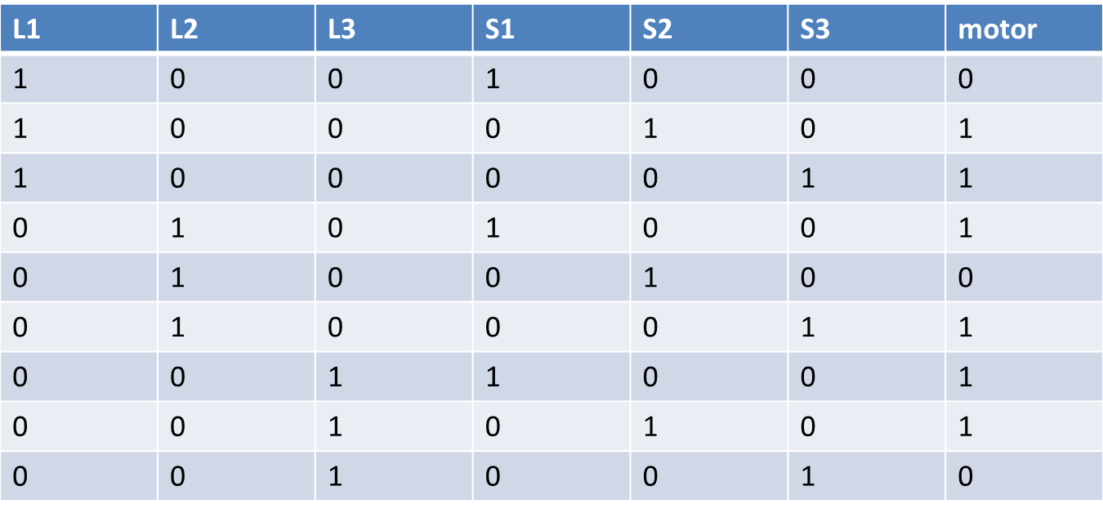

Table (2): Motor

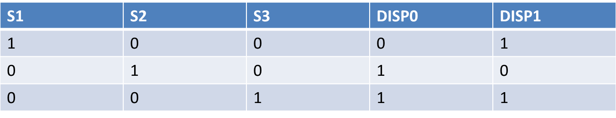

Table (3): 7-segment Display

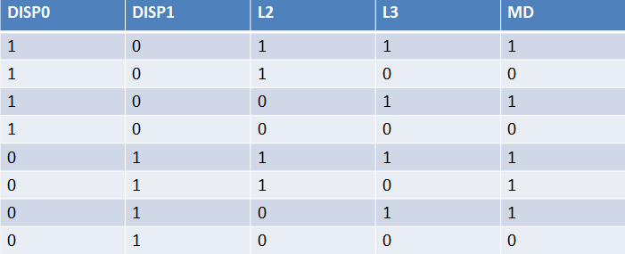

Table (4): Motor Direction

* 1. 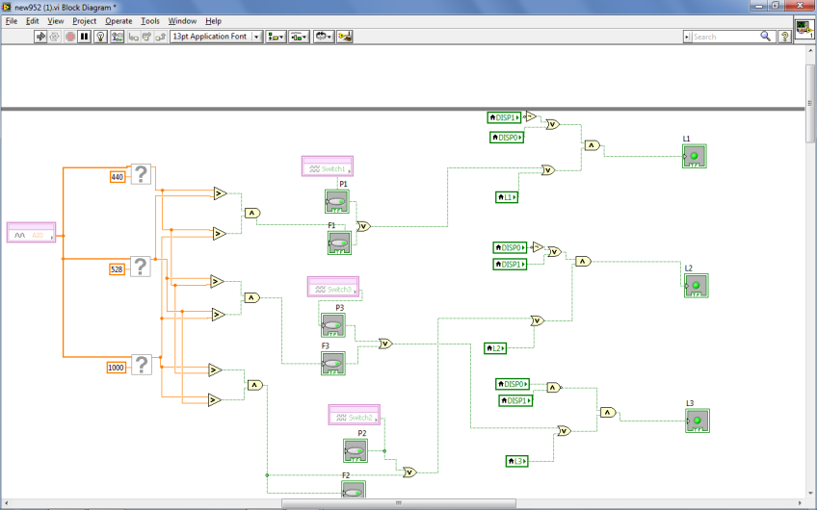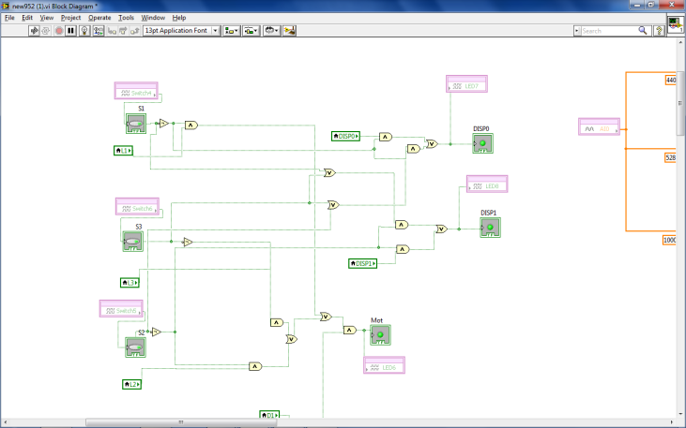Afterwards, when the basic software was finished, it had to be tested on SPEEDY and some of the elements replaced by SPEEDY switches and LEDs. This is a sample snapshot of what it looked like:

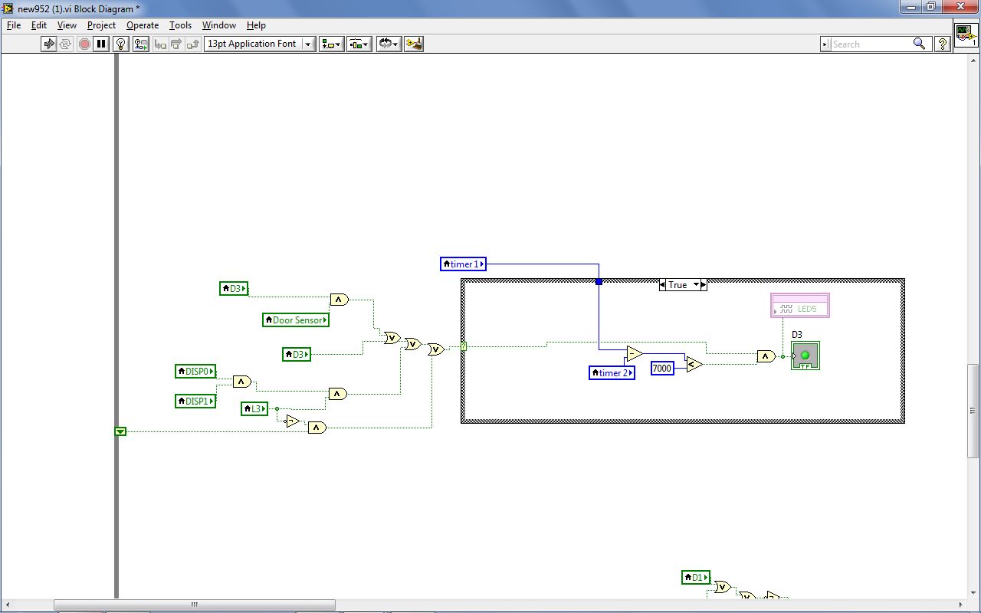

1. Hardware:
   1. Brainstorming was done and the following was come up with:
      1. Wood will be used for the hardware
      2. SPEEDY would be hid at the base
      3. A rail should be nailed to keep the cabin on track
   2. A set of wood was bought and the design was carpented as a rectangular prism.
   3. Bump Sensors were glued to the edge of each floor:
   4. The motor was nailed to the upper side of the design
   5. A sturdy rope was circled around the motor and the pulley
   6. The DC fan was nailed to the top of the cabin
   7. CD-ROMS were used as doors and glued to the edge of each floor
   8. Rubber bands were placed to make the doors close automatically

**Considered designs and final designs:**

|  |  |
| --- | --- |
| Considered Designs | Final Design |
| Use of plexiglass | No plexiglass was used |
| Use of “Delay” function | Tick count was used instead |
| Use of nails to pin the sensors | Mostly glue was used |
| Implementing the rail the backside of the cabin | The rail was implemented at theedge of the cabin |

Table (5)

**Design Photos:**

**Hardware: Software:**

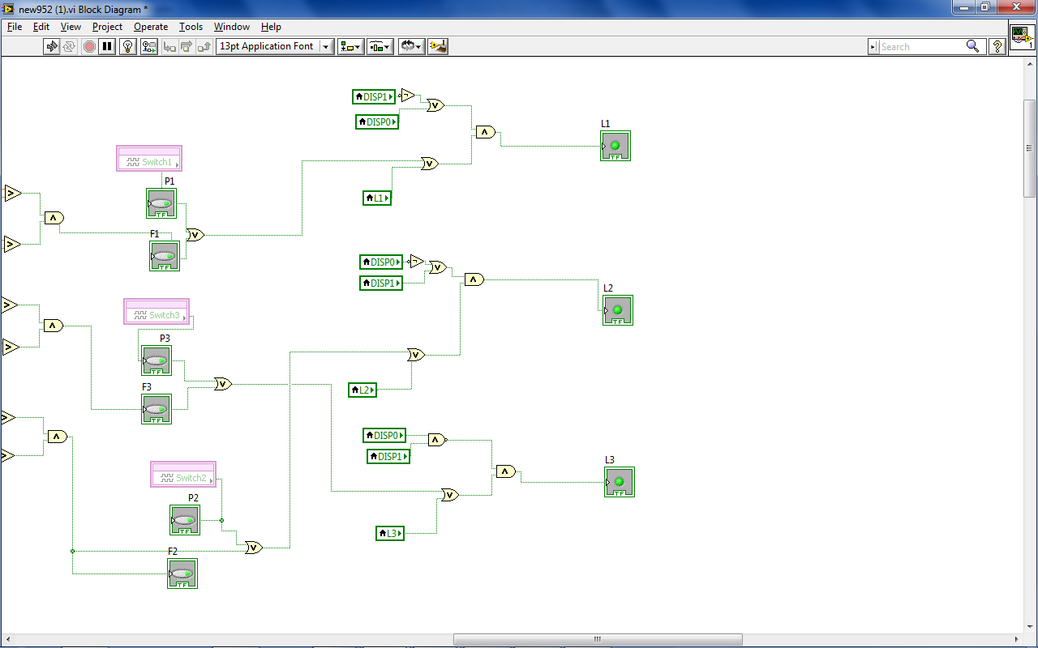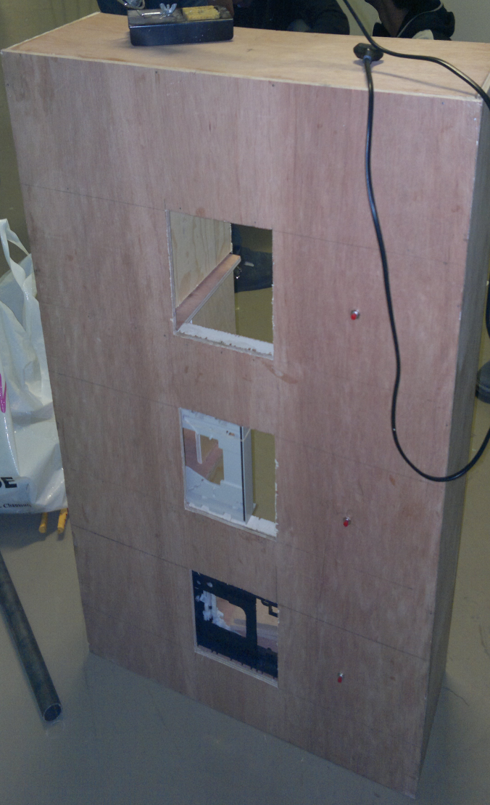

**Testing and Results:**

The software was tested on SPEEDY and its switches and LEDs were represented on the LABVIEW software itself; however, for testing the software on the hardware the SPEEDY boards were taken from us unfortunately before testing would even begin. There were also some malfunctioning SPEEDY boards that didn’t help at all. But we managed to test the motor using the DC power supply and moved as it should, and the cabin clicked all the bump sensors on its way up and down the rail of the elevator. The doors were also tested using the DC power supply, they opened on a certain connection, and when it was stopped the rubber band automatically closed them.

**Anticipated Costs vs Real Costs:**

|  |  |  |  |
| --- | --- | --- | --- |
| Item | Quantity | Anticipated Price ($) | Real Price  ($) |
| SPEEDY-33 | 1 | 600 | 600 |
| Plexiglass Model | 1 | 250 | N/A |
| Wooden Model | 1 | 25 | 40 |
| Motor | 2 | 6 | 5 |
| Temperature Sensor | 2 | 4 | 3 |
| Fan | 2 | 4 | 2 |
| Bump Sensor | 5 | 2.5 | 3 |
| Motion Sensor | 5 | 5 | 3 |
| LED | 10 | 5 | 2 |
| Aesthetics | - | 15 | 10 |
| Switch | 10 | 5 | 6 |
| Seven Segment Display | 3 | 1.5 | N/A |
| Total | 41 | 923 | 674 |

Table (6): Real costs vs anticipated ones

**Individual Contributions of Team Members:**

* + - * **XXXX:** Contributed the most to the software and the wooden part of the hardware, as well as the reports
      * **XXXXX:** Contributed to the software and the wiring of the hardware pieces, as well as the reports
      * **XXXX:** Contributed to the gluing and pinning phases of the hardware, as well as the reports
      * **XXXX:** Contributed to the finalization and structure of the hardware, as well as the reports

**Conclusions and Recommendations:**

* + - * Nothing will be given, one has to go out in the field and search for it
      * Computer engineers are not fully dependent on programming and software, but also work with hardware
      * We recommend having a shop in AUB that sells the needed equipment for such projects
      * We also recommend using a DSP module more efficient than SPEEDY

**References:**

1. S.Howard: “Report Writing Writing” (E-Book)
2. Scribd: <http://www.scribd.com/doc/7072695/Elevator-Design-and-Control-Simulation-Using-LabVIEW-2003>
3. YouTube: <http://www.youtube.com/watch?v=TWlv12MU0vwg>